- INTRODUCTION
Flexible hose assemblies (FHA) are the most frequently used equipment in fuel depots, fuel transport and service stations. Because of the intense use, the flexible hoses are likely to suffer from wear and tear. Improper hose materials, maintenance, storage and use can lead to hose failure.

- SCOPE & RISKS
- Definitions:  - Flexible Hose Assemblies (FHA) =  - flexible hose itself +  - fittings which are part of the assembly  - Included are FHA for product transfers:  - at service stations  - at fuel depots  - on road tankers  - on barges  - Excluded are:  - hoses integral with vehicles and machinery  - fire hoses  - low pressure water hoses  - hose fittings which are not part of the FHA  - semi-flexible hoses for connecting piping to dispensers (under- and above ground)  - customer heating oil installations | Examples of included FHA:  Depots, FHA for:  - train unloading  - barge (un)loading  - truck (un)loading  - tank transfers  - draining tanks  Service stations, FHA at:  - gasoline dispensers  - diesel dispensers  - LPG dispensers  - two stroke dispensers  - red gasoil dispensers  - LNG dispensers  - CNG dispensers  - Electric chargers  Road tankers:  - fixed FHA reels  - detachable unloading FHA  - joints/connections for difficult filling points
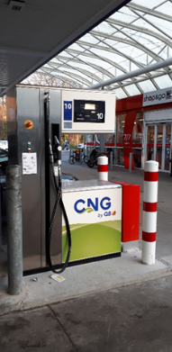
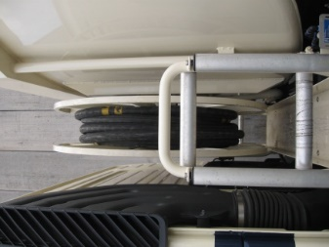
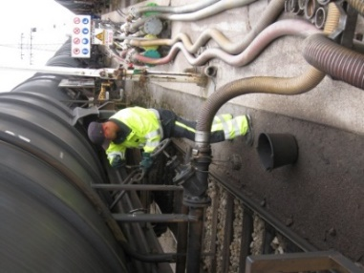
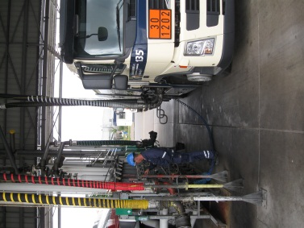

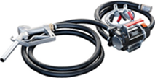
- Hose failure presents Risks :
- spills of hazardous products
- explosions and fires when vapours of spilled fuels ignite
- personal injuries when spilled fuels/vapours end up in/on the human body
- soil and water contamination when spilled fuel penetrates the ground and/or reaches surface
- waters

- SAFETY REQUIREMENTS
ALWAYS: CHECK
- WHEN PURCHASED, FLEXIBLE HOSE ASSEMBLIES MUST BE
- compliant with local legal requirements*
NOTE: when purchased, legal replacement requirements must be taken into
account. As the occasion arises, one should make sure that hoses are
not older than 3 to 6 months when delivered.
- supplied by approved manufacturers or suppliers/assemblers
- appropriate for the selected application
- accompanied by formal certificates containing typical details* like:
- Manufacturer’s name**
Date of manufacturing
≠
Date of first use
AVOID BUYING OLD FHA!
- Manufacturer’s batch number**
- Manufacturing standard
- Unique identification number
- Materials of construction
- Service application
- Test pressure
- Maximum working and burst pressure
- Year and month of manufacture
- Rubber hose: certificate stating that no adipates and/or phthalates were used in the rubber
* In case of FHA on fuel depots, the certificates contain also: (1) lenght and diameter of the FHA, (2) type of fitting for both ends and (3) conductivity.
** When bought through a supplier, both manufacturer and supplier/assembler data must be indicated on the certificate!
- physically labelled or marked with details like (see pictures below):
- Unique identification number
- Year and month of manufacture ≠ date of first use !!!
- Maximum working pressure and pressure resistance
- working pressure / Test pressure
- …
- IDENTIFICATION OF FLEXIBLE HOSE ASSEMBLIES
Each FHA must be identified for maintenance and replacement matters. This can be obtained by e.g.
- printed manufacturing data on the flexible hose and/or
- tag with data around the hose if feasible and/or
- inalterable unique ID number (e.g. engraved in the couplings referring to the certificate and/or register)
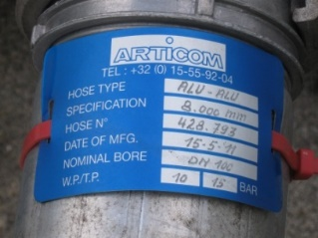
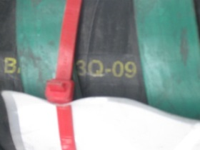
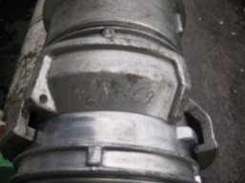

ALWAYS
CHECK
- STORAGE OF FLEXIBLE HOSE ASSEMBLIES
FHA can be stored as a spare part stock (easy replacement) or when not used all the time. When FHA are stored, this must be taken into account:
- clean and dry conditions for storage
- away from direct sunlight, corrosive substances and mechanical damage
- sealed hose ends to prevent ingress of dirt
- laid straight out and supported along their lengths
(except when supplied in coiled lengths)
- avoid to store other items on top of the FHA
- inspection (and/or testing) of stored FHA
    - always prior to commissioning and
    - periodically when required (law, manufacturer, standard …)
- respect the maximum lifetime as recommended by the manufacturer
    - stored FHA reaching the maximum allowed lifetime must be scrapped
    - where the age of stored FHA cannot be determined from records or markings, it should be scrapped
- VISUAL INSPECTION AND/OR TESTING

- Inspection and/or testing frequency and requirements
depend on:
    - manufacturer’s/assembler’s advice
    - criticality of service
    - consequence of a FHA failure
    - FHA operating environment
⇒ Attention: the test and inspection requirements and intervals must comply with the ones determined in local law, national standard or insurance stipulations
- Test type, can differ but are typically one of these:
    - 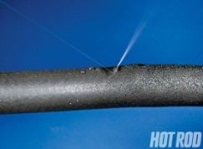hydrostatic pressure test (e.g. at depots)

    - air pressure test (e.g. for road tanker FHA)
    - vacuum test (e.g. at service stations)
    - electric resistance test (e.g. at service stations)
    - …

⇒ CAUTION: when test results are not consistent with the requirements, the FHA should be removed from service immediately and formally recorded

ALWAYS CHECK
- Visual inspection, at least following items should be examined
    - irregularities in the outside diameter, e.g. kinking
    - damage or exposed reinforcement of permanent deformation
of the hose outer cover, e.g. soft spots, blisters, bulges, cracks
    - damage of the end fittings
    - improvised repair (e.g. tape …)
    - storage requirements (see above, point 3)
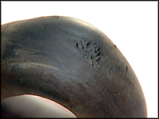
    - sealing when not in use
    - hose or coupling marking/tagging quality
    - …
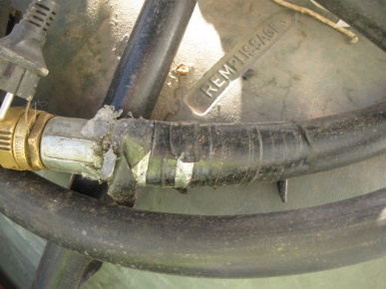
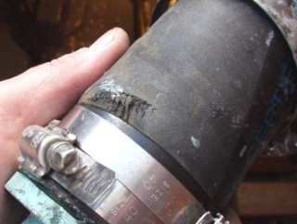

⇒ CAUTION: when defects are discovered the FHA should be removed immediately from service and this has to be formally recorded
- Competency: persons who perform visual inspections and/or contractors who perform tests must have provable capabilities. Inspections and/or test performed by contractors have to be done according the local legislation, national norms, requirements of the insurance or according the technical requirements of the manufacturer
- Records: inspections, tests and results must be recorded formally and the related documents become part of the register (see point 6). This data has to be traceable in the intervention reports of the competent contractor
- REPLACEMENT
- NO MAINTENANCE REPAIRS should be carried out
⇒ REMARK: maintenance of FHA will be limited to the follow-up and recording of visual inspections, periodic testing and timely replacement of FHA
- Removal and REPLACEMENT of the FHA is required WHEN:
    - visual inspections show defects (see point 4) or
BETTER
SAFE
THAN
SORRY
    - test results are not consistent with the requirements (see point 4) or
    - FHA are (possibly) damaged in incidents (see point 9), e.g. absent minded customer at a service station rips off nozzle/hose; FHA is overrun by a truck; or
    - FHA reach the maximum allowed lifetime as determined by local law, national standard, insurance stipulations or the manufacturer*. (starting from the date of manufacturing – not the date of first use and regardless of damage or not or whether it is used or stored) or
    - the age of the FHA can no longer be determined from records or physical markings

ALWAYS CHECK
- REGISTER
- Purpose
    - inventory with
    - essential details on FHA and
FHA Register =
FHA certificate
+
Inspection records
and/or
Test records
+
Disposal records
    - historical performance data, also useful as
    - incident investigation support information
and evidence
- Data management
Typical information that is held in the register will be:
    - unique identification number
    - year of manufacture
    - hose details
    - date of last inspection
    - date of next inspection
    - status at last inspection
    - relevant historical information
TIP: Use existing - often atomised maintenance systems to collect all data and to follow-up inspection and replacement
- Competency
Staff nominated for maintaining the FHA register should be properly trained
- FLEXIBLE HOSE HANDLING & USE
- FHA should remain substantially straight or evenly curved when lifted/used
Avoid lifting or supporting FHA from one single point with the ends hanging down
- Put in place additional control measures for preventing
    - tripping hazards from FHA across walkways/traffic routes
    - back injuries from heavy FHA; install lifting aids
    - FHA chafing against any rough surface, dock or ship/lighter







    - FHA lying in oil residue or other liquids that may damage rubber compounds
- Supply all required PPE to staff using FHA
- When FHA are left in position after use, make sure:
    - if still product in FHA: make the expansion of the product in the FHA possible
    - if still product in FHA and expansion is not possible, drain the FHA, protection against physical damage and seal the ends to prevent emanation, also prevent dirt and dust

TIP: when FHA are not used for a longer time, one should consider to return them to the storage or shelter area to prevent wear and tear, including wear due to unfavourable weather conditions
ALWAYS
CHECK
- DECOMMISSIONING & WASTE
- Used FHA which will be stored as useable spare, must be rinsed, cleaned, ends sealed, and properly stored (see point 3 and 7)
- FHA, used or stored, which are no longer fit for purpose:
    - must be rinsed and has to be dry
    - should have the end fittings removed
(or one can consider to cut the FHA in two if this can be done in a safe way)
    - the whole marked as “scrap” or other visible indication
    - disposed of in line with local waste regulations
- The FHA register must be updated accordingly
- The data regarding the decommissioning and waste management has to be traceable in the intervention reports of the competent contractor
- INCIDENT REPORTING
- Incidents must be reported, e.g.
    - absent minded customer ripping off nozzle/hose
    - spills from failing hoses and/or connections
    - injuries as result of failing FHA, such as: the connection jumps away hurting a body part, fuel ended up in the eyes or on the body, escaped vapours were inhaled, …
    - fire and explosions due to hose failure spills
- Near misses must be reported timely in order to prevent incidents, e.g.
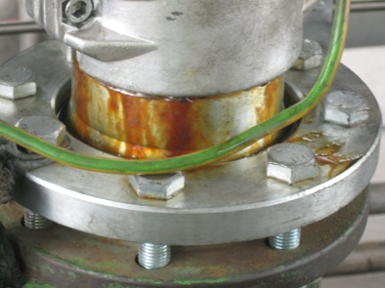
    - cracks in hoses
    - loose fittings
    - fuel FHA used for other purposes
    - hoses overrun by a heavy vehicle
    - deformed hoses
    - connections showing traces of or small fuel leakages/drops (no spill yet)
    - abnormal sweating of hoses
    - variations in hardness of the rubber
- Damaged and suspicious FHA must be removed – NOT REPAIRED
The FHA register must be updated accordingly
- FHA MANAGEMENT REQUIREMENTS
- Always check local legal requirements, requirements of the insurance if present and the requirements of the manufacturer for FHA Management
- An overview of FHA standards can be found on the website of the
European Committee for Standardization: CEN FHA Standards
(Rubber and plastics hoses and hose assemblies - Published standards)

KUWAIT PETROLEUM NORTH WEST EUROPE

DOCUMENT TITLE: TSR - Flexible Hose Assemblies

DOCUMENT NUMBER: KPNWE.WI.11.HSCO.087

REVIEW NUMBER: 1

EFFECTIVE DATE: 01 Dec 2020

NEXT REVIEW DATE: 01 Dec 2023
..

CONFIDENTIALITY:
The information contained in this document is confidential to Kuwait Petroleum International Ltd. Copyright © Kuwait Petroleum International Ltd. Copying of this document in any format is not permitted without written permission from the management of Kuwait Petroleum International Ltd.

This document is reviewed and approved according to the released online Document Approval Flow

Prepared by: | Operational Assistant | An Cornelis
Reviewed by: | Operational Assistant | An Cornelis
Approved by: | QHSSE Manager | Patrick De Baere

*Access rights: Generally Accessible

Reviews Summary

Review date | Review reference | Review details | Review version
01 Dec 2017 |  |  | 0
01 Dec 2020 | -- | Periodic review - general update | 1

